Unit Management
Chapter
7
This Unit Management package provides library services for organizing groups of units of measure. It is common for bridge engineering applications to have different unit modes. The typical modes are SI and English. The unit modes allow the user to work with a logically organized subset of the available units of measure. The Unit Library service can be used to organize named subsets of units of measure. The Unit Library service is template based so that it usable for any grouping of the units of measure. A default unit of measure grouping, unitmgtIndirectMeasure, is provided. This class is designed to provide indirect units of measure to output services such as reporting and graphing.
Units of measure can be group in many ways other than by unit system. Another possible grouping, and possible unit mode of an application, could be big units and small units. The units of measure one would use for a highway bridge and different than the units of measure one would use of a micro-machine.

Unit Library
The Unit Library service provides a mechanism for storing and retrieving named sets of units of measure. The core code of this service is in the form of templates, allowing the unit library to be used for any unit of measure grouping.

Requirements
The unit library must not:
- restrict how units of measure are group
- restrict the abstract unit of measure names
- restrict the lookup names (keys) for unit of measure groups

Logical Design
The unit library service consists of two primary classes and a template instantiation, the unit library template, one implementation for a grouping of units of measure, and an instance of the unit library template.
The unit library is implemented in unitmgtLibraryT, a template class whose template argument is the type of the value stored in the library. Library entries consist of a lookup key and a value. The lookup key is a string name and the value is of type T (the template argument type).
The class unitmgtIndirectMeasure is a utility class consisting of static data members that represent various abstract units of measure and an associated zeroness. Zeroness is a quality used to filter out noise in output. Basically zeroness means if the united value, after conversion, is smaller than a given value, the converted value is set to zero. This is preferable to having insignificant numbers confuse output. Zeroness is however dependent on the unit of measure that is used and what the united value represents.
The class unitmgtLibrary is an instantation of untmgtLibraryT using unitmgtIndirectMeasure as the template parameter.

Static Models
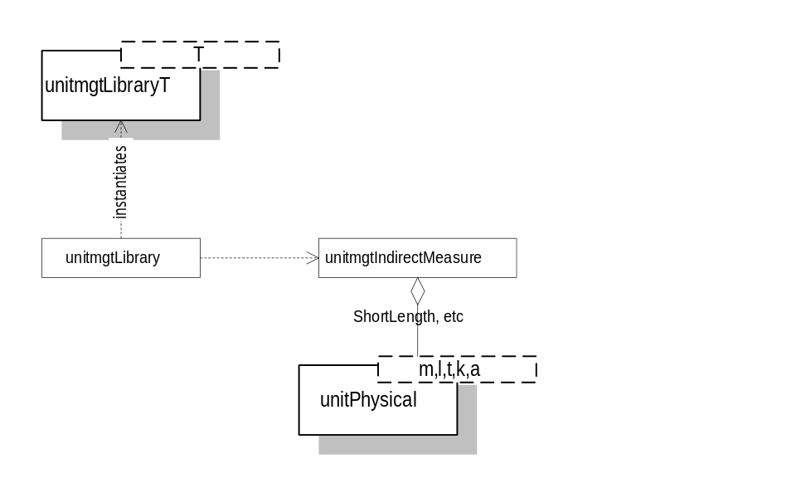

Dynamic Models

Physical Design

Specifications

template<class T> unitmgtLibraryT
Template class for a unit library. This class provides library services that can be used to categorize indirect units of measure.

Public Interface - Member Functions
unitmgtLibraryT
unitmgtLibraryT()
Constructor.
~unitmgtLibraryT
~unitmgtLibraryT()
Destructor
AddEntry
void AddEntry(const std::string& key, const T& value);
Adds an entry to the library
RemoveEntry
void RemoveEntry(const std::string& key);
Removes an entry from the library. If an entry could not be found, throws a unitmgtLibraryT::XEntryNotFound exception.
GetEntry
const T& GetEntry(const std::string& key) const;
T GetEntry(const std::string& key);
Gets a library entry whose key is equal to key. The first form returns a reference to the value associated with key, the second form returns a copy. If an entry could not be found, a unitmgtLibraryT::XEntryNotFound exception will be thrown.
Contains
bool Contains(const std::string& key) const;
Returns true if the library contains an entry whose key is key, otherwise returns false.

template<class T> unitmgtLibraryT::XEntryNotFound
Nested exception class. Thrown when the specified library entry could not be found.

Public Interface - Member Functions
unitmgtLibraryT::XEntryNotFound
unitmgtLibraryT::XEntryNotFound(const unitmgtLibraryT::XEntryNotFound& rOther);
Copy constructor
operator =
unitmgtLibraryT::XEntryNotFound operator=(const unitmgtLibraryT::XEntryNotFound& rOther);
Assignment operator.
Is this needed if there is no default constructor? Check for consistency with all exception classes
GetOffendingKey
std::string GetOffendingKey();
Returns the offending key.

Implementation Notes
All constructors other than the copy constructor should be declared private. This limits the creation of this type of exception to unitmgtLibraryT. XEntryNotFound must grant unitmgtLibraryT friendship rights so that it can create exception objects of this type.

unitmgtIndirectMeasure
This is a POD struct that encapsulates variables for indirect units of measure and the zeroness of the units of measure. This class is intended to be used as an entry value for unitmgtLibraryT.

Public Interface - Data Members
The ms_ prefix has been dropped for clarity.
StationFormat
static unitStationFormat StationFormat;
A station format object. The default value is unitStationFormats::SI.
Indirect unit of measure  Signature | Default value
static unitLength ShortLength; | unitMeasure::Millimeter
static unitLength RegLength; | unitMeasure::Meter
static unitLength LongLength; | unitMeasure::Kilometer
static unitLength2 RegArea; | unitMeasure::Millimeter2
static unitLength2 BigArea; | unitMeasure::Meter2
static unitLength3 RegVolume; | unitMeasure::Millimeter3
static unitLength3 BigVolume; | unitMeasure::Meter3
static unitLength4 MomInertia; | unitMeasure::Millimeter4
static unitForce RegForce; | unitMeasure::Newton
static unitForce BigForce; | unitMeasure::Kilonewton
static unitMoment RegMoment; | unitMeasure::NewtonMeter
static unitMoment BigMoment; | unitMeasure::KilonewtonMeter
static unitPressure RegStress; | unitMeasure::Pa
static unitPressure BigStress; | unitMeasure::MPa

Zeroness Signature | Default value
static Float64 ShortLengthTolerance; | 0
static Float64 RegLengthTolerance; | 0
static Float64 LongLengthTolerance; | 0
static Float64 RegAreaTolerance; | 0
static Float64 BigAreaTolerance; | 0
static Float64 RegVolumeTolerance; | 0
static Float64 BigVolumeTolerance; | 0
static Float64 MomInertiaTolerance; | 0
static Float64 RegForceTolerance; | 0
static Float64 BigForceTolerance; | 0
static Float64 RegMomentTolerance; | 0
static Float64 BigMomentTolerance; | 0
static Float64 RegStressTolerance; | 0
static Float64 BigStressTolerance; | 0

unitmgtLibraryT<unitmgtIndirectMeasure> (unitmgtLibrary)
This class is an instantiation of the unitmgtLibraryT template class using the unitmgtIndirectMeasure class as the library entry value type. For ease of use, the template name is typedefed to unitmgtLibrary.

